 | Cambridge Mathematics Stage 2  Name: ………………………………………………….  Class: …………… Date: ……………………… /13
Week 7 Homework - Unit 5: Working with numbers to 100
- Fill in the times tables grids.
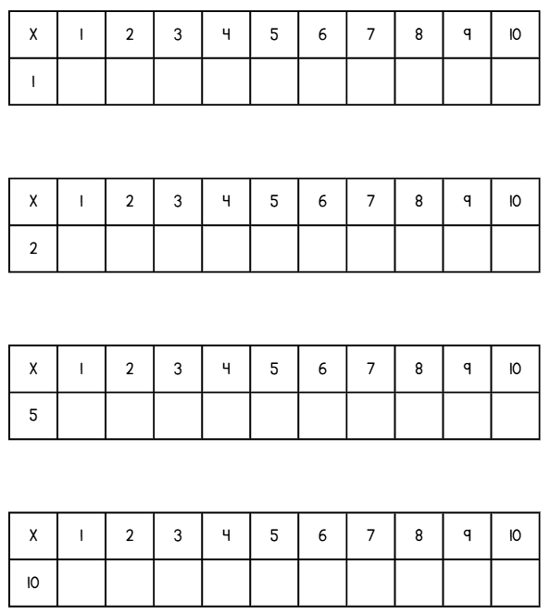
(4 marks)
- Fill in the multiplication sums from the array.
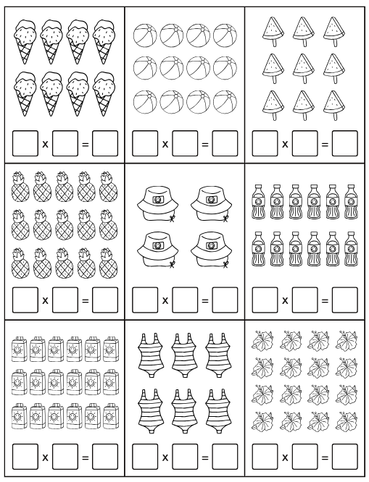
(9 marks)

